# MINI PROJECT

**(2020-2021)**

# Cloud-Based E-book Website

# REPORT



**Institute of Engineering & Technology**

**Team Members**

Priyansh Agrawal (181500510)

Krishan (181500328)

Ashutosh Kumar(181500149)

Ankit Kumar (181500097)

Nitin Goyal (181500432)

## *Supervised By*

**Mrs. Harvinder Kaur Mam**

**Department of Computer Engineering & Applications**

Contents

# Abstract

# 1. Introduction

## 1.1 General Introduction to the topic

## 1.2 Area of Computer science

## 1.3 Hardware and software Requirements

## 1.4 Description of Languages used

# 2. Problem definition

# 3. Objectives

# 4. Implementation Details

# 5. Progress till Date & The Remaining work

# 6. Some Screenshots

# 7. References

# Abstract

The main objective of the project is to create an online book store that allows users to search and download a book online based on title, author and subject. The selected books are displayed in a tabular format . Using this Website the user can download a book online instead of going out to a book store and wasting time.

There are many online book stores like Powell’s, Amazon which were designed by the purpose of earning profit either by directly selling books or showing adds. we want to develop a similar website for the purpose of helping users by providing a simple way to get a book.

Online Book store will be a basic website where the user can download books online. Through a web browser the users can search for a book by its title or author, later download in pdf form and enjoy reading it. The user can login using his account details or new customers can set up an account very quickly. They should give the details of their name, contact number and profession . The user can also give ratings to a book. The books are divided into many categories based on subject like Software, Database, English, Python etc.

The Administrator will have additional functionalities when compared to the common user. He can add, delete and update the book details, book categories, member information .

This website is developed using HTML, CSS and JAVASCRIPT.

# Introduction

## General Introduction to the topic

This is a project with the objective to develop a basic website  where the user can download books online. Through a web browser the users can search for a book by its title or author, later download in pdf form and enjoy reading it. The user can login using his account details or new customers can set up an account very quickly. They should give the details of their name, contact number and profession . The user can also give ratings to a book. The books are divided into many categories based on subject like Software, Database, English, Python etc.

### Ebook

An electronic book also known a e-book, It is a book publication available in digital form, consisting of text, images or both, readable on the flat panel display of computers or other electronic devices. E-books can be

read on dedicated e-reader devices, but also on any computer device that features a controllable viewing screen,including desktop computers,laptops,tablets,and smart phones.



## Area of Computer Science



E-learning is a learning system based on formalised teaching but with the help of electronic resources is known as E-learning.

In the field of E-learning books are the most important part. An ebook is just an electronic format of a book. The main benefits of ebooks are mobility as you can access them anywhere , anytime ,using any device. Ebooks needs very less care as these can’t be lost or damage by the effect of time .One more benefit is that as these books required zero physical space for storage.

## 1.3 Hardware and Software Requirements

### Hardware

• Memory [4GB RAM (or higher)]

• Intel core i3 64-bit Processor (or higher)

### Software

Operating System: Windows.

Languages: Python,HTML,CSS,Javascript

## 1.4 Description of Languages used

### HTML(hypertext markup language)-

Hypertext markup language(HTML) is the standard markup language for documents designed to be displayed in a web browser. It can be assisted by technologies such as CSS and JS.

Here the purpose of using Html in E-book website is to describe the structure of website Example in Front page of our website i.e Home page in Login and Signup form etc.

The following example describes that how html is use in website:-

#### Example-

<html>

<head>

<title>ebook website</title>

<body>

<h1>welcome to our website</h1>

<a href =”click here for login”</a>

</body>

</head>

</html>

### CSS3(cascading style sheets)-

Cascading style spreadsheets is the language for describing the presentation of web-pages,including color layout and fonts. It allow one to adopt the presentation to different types of devices.

Here It is based on Html code and set design space,size of all pages of our website.The given example describes that how we use CSS in our website.

#### Example-

.header{

Background-color: #F1F1F1;

Text-align: center;

Padding:20px;

Background-color: #F2F2F2;

Text-align: center;

Padding:25px;

}

## Java Script-

JavaSript allows to create highly responsive interfaces that improve the user experience and provide dynamic functionality without having to wait for the server to react and show another page.

Here JS creates a highly responsive interfaces and helps to make it dynamic and interactive by implementing by client side.The following example show how JS use -

#### Example-

Var i;

Var l=arr.length;

for(i=0;i<l;i++)

Var obj;

obj=

document.getElementId(“demo”);

obj.innerHTML=”Hello”;

# 2. Problem Definition

The library provides a limited amount of types of books. Usually the library provides hard covered books meant for research, educational purposes and historical readings .The section for leisure reading is limited to certain type of books not always appealing to everyone.

A person who want to read book but unable to go in library .

He/ She can easily use ebook website without any problem. An increase in quality of educational resources helps to create the quality in any type of class instruction and research .Since there exists a limited space in library to store all these books; Online book is the best approach to provide quality to everyone.

Even when a user go for an online solution , websites are full of fake contents having a lot of adds or demanding money.

Our goal is to provide a simple way to get a pdf format of a book . User just login to their respective account then search for their required book by title , name of the author or simply by categories provided by the admin.

# 3. Objective

The main objective of creating this website is to provide users a simple way of getting pdf format of any book. Currently there are many websites which provide pdf formats of the books like amazon kindle but the problem with these kind of things is that these are created purely with the means of earning profit .

Our website will be a completely a non profit earning by any means like selling books or showing ads. It will be solely dedicated to provide simplicity , ease of use to our users.

# 4. Implementation details

## 1) A Home page with product catalog

This is the page where the user will be navigated after a successful login. It will display all the book categories and will have a search keyword option to search for the required book. It also includes some special sections like recommended titles, weekly special books.

## 2) Search

A search by keyword option is provided to the user using a textbox .The keyword to be entered should be the book title.

## 3) Advanced Search

Advanced search helps the user to search for a book based on Title, Author and Category. All the books which match the particular search criteria and their total count will be displayed .From here the user can select a book and add to the shopping cart.

## 4) Book Description

If the user would like to know details about a book he can click on the title from where he will be directed to a Book description page. It includes the notes on the book content and also a link to Amazon.com to get the book review.

## 5) User Voting

The user can give rating to a book based on his interest. He can rate it by giving a score of five as Excellent, four for very good, three for good, two for regular and one for deficient. The final rating of a book will depend on all the individual user rating.

## 6) Download button and icon

when user will click on it the download will begin and after the download finishes the book will be avialable offline for user in his download section.

## 7) Managing user accounts

Each user should have an account to access all the functionalities of website. User can login using login page and logout using the logout page. All the user sessions will be saved in the database.

## 8) Administration

The Administrator will be provided with special functionalities like

• Add or delete a book category

• Add or delete a member

• Manage member orders.

• Add or delete a Credit Card type.

### https://secureservercdn.net/160.153.137.210/11v.681.myftpupload.com/wp-content/uploads/2017/08/E-learning-First-Level-DFD-For-Admin.png

# 5. Progress till date & Remaining work

## Progress till date

### 1) Login

• Purpose: If the User wants to get access to all the facilities of Online Book Store he should login using his username and password.

• Actor: User

• Input: The User will enter his username and password.

• Output: If it is a successful login the User will be directed to his menu page. Else if the User enters invalid information he will be asked to check the entered information.

### 2) Search

• Purpose: If the User want to search any book on the basis of the categories , title of the book or author of the book .

• Actor: User

• Input: If the User wants to search a book then he should select the perimeter on the basic of which he wants to perform the search then he type the name of the perimeter in the box and finally click the search button .

• Output: If the result is founded and then displayed to the user else a sorry message will be displayed to the user.

## Remaining work

The work adding functionality and adding more categories and books is in progress and will be complete very soon .

* Book description
* Adding and deleting books & categories
* Voting system
* Download button and icon

# 6. Screenshots

# 

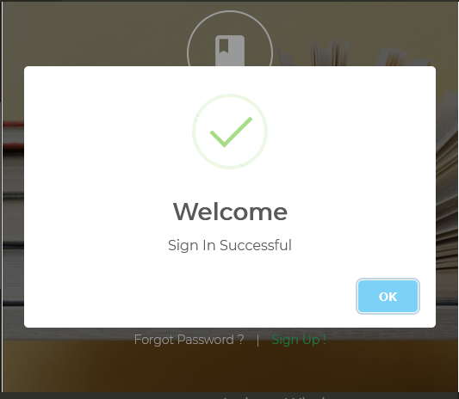

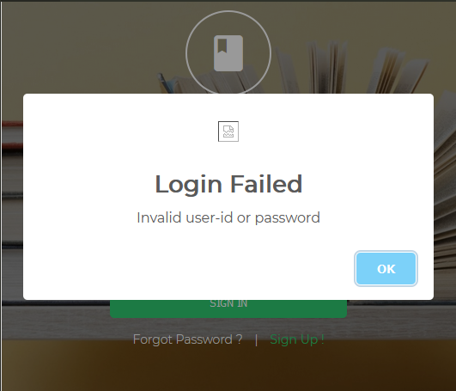

# 

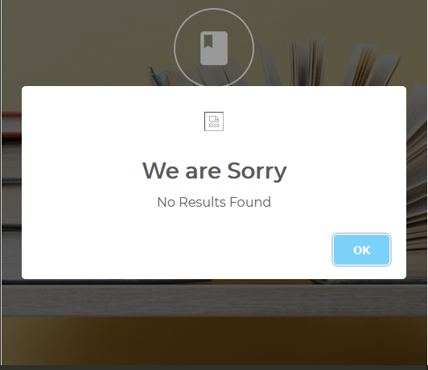

# 7. References

1)[www.google.com](http://www.google.com)

2)[www.Wikipedia.com](http://www.wikipedia.com)

3)[www.w3schools.com](http://www.w3schools.com)

